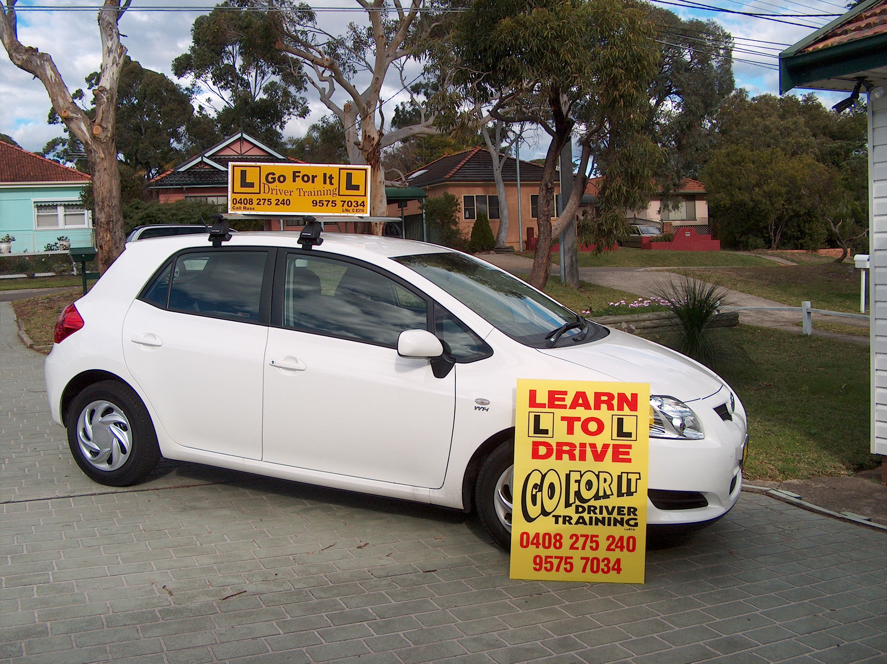

Learning targets for Complex program

You no longer feel as though you are in a car driven by a learner. The student’s basic control skills are now accurate and are becoming smooth. No longer does each driving task appear to be a separate action- they are merging.

The learner can do a tight manoeuvre, such as a three-point turn in a narrow street on a slight incline and explain why certain techniques they use in the manoeuvre are important.

Mistakes in using basic controls are now rare and they don’t trouble the learner. E.g. stalling the car, they quickly restart the car and continue as if nothing had happened.

The student now fits in well with other traffic. Other road users do not have to make adjustments for the learner.

The learner also notices when they don’t get the road rules right and say what they should have done. Their explanations include reasons why the action was unsafe.

The learner can drive and at the same time see, interpret, explain and respond appropriately to every road sign as it becomes legible.
The student can answer a question about the road rules as they apply to a situation they are in. They can do this in a reasonably busy traffic situation.

The learner can judge how fast they are going and they adjust their speed to suit the conditions without being told (sometimes).

They can talk about traffic situations ahead of them, recognize the hazard, understand the defense, and act in time.

When other’s mistakes force them to brake, they can work out the reason they did not anticipate it.

Comments

